CMP1903M Object Oriented Programming 2024 – 2025

Assignment 2: Report
[Expand the sections as necessary]
Name: Morgan Osborn
Student ID: 2960598
Code repository URL:
Video URL:

Application:
- Reflection on the OO features within your code. (~400 words)
In my Game class within my solution showcase several core principles of object-oriented programming, which includes encapsulation, abstraction, inheritance and polymorphism. These principles work together to create a maintainable, scalable and extremely well-structured codebase that clearly separates responsibilities across different components and areas within my solution.
One of the most important and evident OOP principles within my game class is the use of encapsulation. Key fields such as ‘_newPlayer’, ‘map’, and ‘_currentRoom’ are all set to private, meaning their state is protected from any modification external to the Game class. Access and modification to these fields are done exclusively through methods like ‘Explore()’, ‘ChangeRoom()’ and ‘StatMenu()’.
This secures each different class within the program because they all manage their own data internally using the private get set fields. By encapsulating logic within their corresponding and appropriate classes, the system becomes easier to test, debug and modify in future.
Furthermore, another closely related principle I have used well is abstraction. The Game class provides an interface to a high standard which allows the player to interact with the game world through commands and prompts such as exploring rooms, battling enemies and even gathering loot. Internally, each of these actions are broken into their own methods.
Also, the Player class within my dungeon game embodies key OOP principles and concepts. Firstly, encapsulation is demonstrated within this class allowing it to maintain control over its own data through a combination of public and private access modifiers. The core attributes such as ‘Name’, ‘Health’, ‘CurrentRoom’, and ‘Inventory’ are exposed through public properties which allows the data stored within them to be passed through different areas of the code.
Abstraction is also effectively employed, the Player class abstracts what it means to be a player within the game. It handles the logic related to movement, combat, and inventory management, without exposing the internal mechanics of these actions are executed and performed. For example, the ‘TakeDamage()’ method internally considers both the raw damage and the players defense before applying health reduction. The consumer of this class only needs to call ‘DamageTaken(damage)’ and does not need to know how the damage is calculated. This abstraction simplifies the logic behind the battle aspect of the game.
- Reflection on your handling of error conditions in your code. (~200 words)
Reflecting upon error handling within the Game and Player classes demonstrate a thoughtful approach to error handling with my focus on defensive programming and maintaining user experience. In the Game class, I have implemented some validation regarding user inputs by utilising ‘int.TryParse()’ and conditional checks within my selection methods. However, the class lacks some structure where I could utilise try-catch handling, which could help with erroneous errors without halting the debugging process.
The Player class takes a more formal approach where I have embodied ‘Debug.Assert()’ to enforce critical preconditions during object creation and method execution. These assertions help catch invalid states early when developing the program, such as null or improperly intialised fields. This proactive strategy ensured the class maintained logical consistency before progressing to more complex interactions.
Looking forward, I aim to improve consistency across classes and the several other classes within the solution by introducing clearer exception hierarchies and fallback mechanisms in the event of errors occurring. This would ensure smoother user experience and aid in the debugging process in the future. Overall, my experience reinforced the importance of anticipating failure points and designing systems that fail gracefully, if they do.

- Reflection on your testing activities: What did you test, and how did you do it? (~400 words)
The testing class in my solution plays a critical role in ensuring that my games core functionalities operate as expected. The primary responsibility of this class is to run automated tests on various parts of the game logic. It then logs the results in a file which a snippet has been included below, allowing this approach to be helpful and essential towards the debugging process of my assignment.

The testing class begins by defining a private filed which holds the file path of the text file which stores the data gathered during testing. This file allows me to look at the tests after they are run and check if anything has failed, and if so, what has failed. It makes it much easier for me to focus my attention on the tests that have failed because of this log file, rather than figuring out which section of the testing has failed to pass.
I have a method named RunTests() which acts as an entry point for initiating the test process. It calls a series of individual test methods such as the Test_Item_Pick_Up(), Test_Connected_Rooms(), Test_Item_Remove(), and Test_Player_Use_Map() methods.
Test_Item_Pick_Up()
This test simulates a player picking up an item and verifies that the item is successfully added to the player’s inventory. It creates a room and an item and then adds the item to the room, then begins to check if the players inventory contains this item after it has been picked up. If it has, this section of the test has passed if not it returns a failure message.
Test_Connected_Rooms()
This method ensures that rooms are properly connected in the game map. It creates two rooms, connects them together and then checks if one room is connected correctly to the other. If the rooms are not connected as expected, then a failure message is written to the log.
Test_Item_Remove()
This test simulates removing an item from a room and verifies that the item is no longer present in the rooms inventory. It creates an item, removes it from the room and then ensures that the item is gone.
Test_Player_Use_Map()
The final test ensures that the player van uses the map item correctly. The player picks up the map, uses it, and the test checks that the map is removed from the inventory after use. If the map remains in the inventory, an exception is thrown. Signalling a failure.
Below I have added a few screenshots of the testing class to show the logic behind the testing.
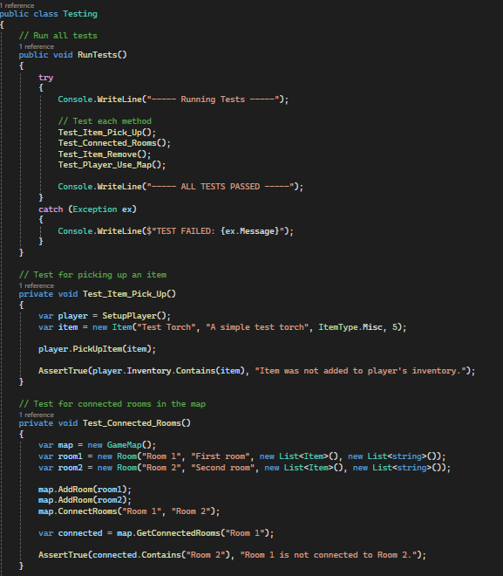

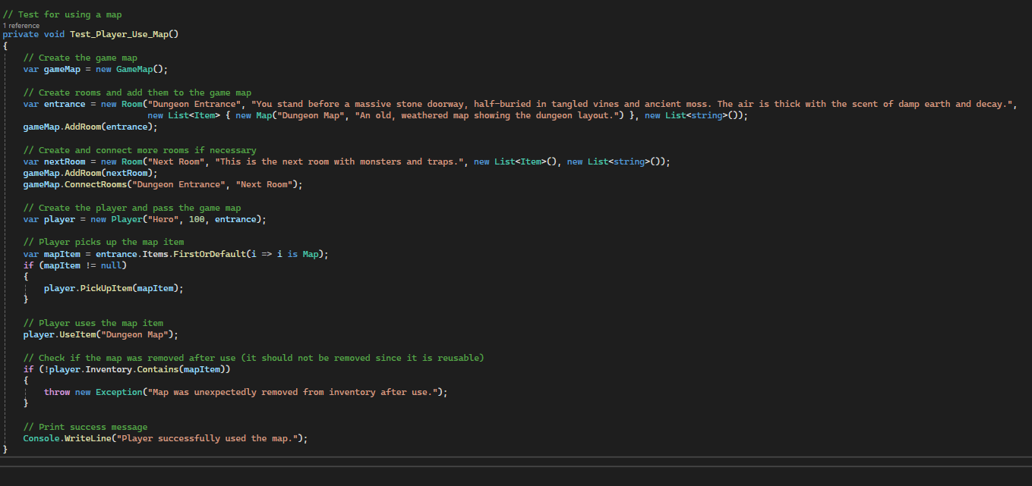
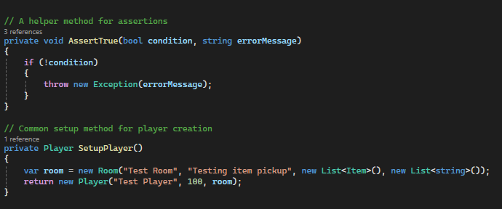

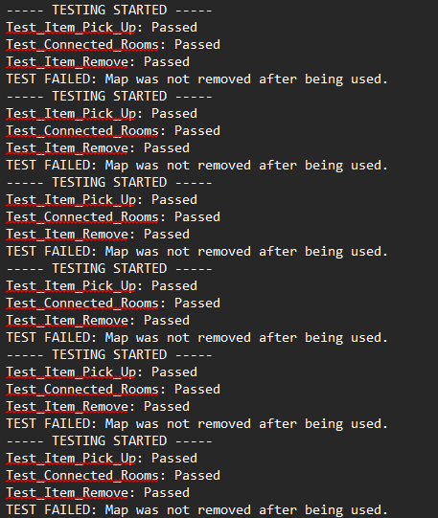
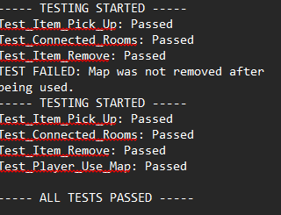
Utilising the test log I managed to fix an error that I occurred where it was using the map, but then attempting to remove it from the inventory even though the map is a miscellaneous item. So I forced the map to stay in the players inventory after use because it is reusable, however in testing the Use() function weas attempting to remove it. Therefore, it was not being removed and then the error occurred.

Reflection & Feedback:
- What was the most important thing you learned from this assessment? (< 200 words)

I think the most important thing I learned from this assessment is the value of planning and structuring your code in a way that you understand and can implement before just beginning to program. Initially, I underestimated how quickly a program can become complex and put you in a state of trance, where you struggle to continue to build onto the solution you are working on. One example would be when working with interconnected classes, as you progress and implement more OOP principles the code you have written tends to depend on each other especially if you are using interfaces, public fields and hierarchical class structures.

More broadly, this assessment reminded me that learning to program and code is not just about syntax and the tools that all the various languages provide, it’s about enjoying it and making it bespoke and personal. Building resilience and becoming determined to solve the issues at hand and make the code yours, many individuals will be completing the same assignment maybe to a better ability or maybe not, but everyone will program in a different way and have a particular approach when they attack a problem. I think that is the most important thing when it comes to an assessment regarding building a project with programming software.

- What was the most challenging aspect of this assessment and how did you approach it? (<200 words)

The most challenging aspect of this assessment was bringing together all parts of the solution-class design, logic implementation, error handling and the user interaction into a cohesive and functional program. I did find it difficult at times to understand what to do next, in terms of how to make my program more complex to reach the higher mark bands, making it hard for me to maintain a clean separation of concerns. I didn’t know what was required first before continuing to make the solution more complex and aiming to amend the code to make it better. I decided to structure the code into many different classes and allow those to communicate and inherit each other, so data could be shared across the solution. This helped me separate my interests across the program so I could focus on one area at a time and then update the other classes whenever necessary.

Despite these difficulties, completing the full solution gave me a clearer understanding of object-oriented design, the importance of error handling and how structured code is both user-friendly, and beneficial to me when I am looking to implement more complex methods to my solution.

- What would you particularly like to receive feedback on in this assessment?
I would particularly appreciate feedback on how I could make my program more efficient and maintainable in terms of organisation and effectiveness. I attempted to follow object-oriented principes utilising abstraction, inheritance, polymorphism and several others but I am unsure if my class responsibilities and interactions are optimally defined.

Assignment 2 Checklist
All of the elements in a section must be checked for it to be considered for that grade (this isn’t guaranteed though). All previous elements must also be complete for a grade to be considered.

Pass standard:
The code compiles and runs. | Yes
The player can explore at least two interconnected rooms. | Yes
Object instantiation, method calls evident. | Yes
Rooms have descriptions and can contain one item or one monster. | Yes
The Testing class is used. | Yes
The player can pick up items and battle monsters. | Yes
Implement at least one abstract class (e.g., Creature) with Player and Monster inheriting from it. | Yes
Use inheritance to define a hierarchy for items (e.g., Item with subclasses Weapon and Potion). | Yes
Demonstrate simple method overriding for Creature subclasses (e.g., different attack methods for Player and Monster). | Yes
Handle invalid commands gracefully without crashing the program. | Yes

2:2 standard:
Include at least three interconnected rooms with navigation between them. | Yes
Rooms can contain multiple items or monsters. | Yes
Implement at least one interface (e.g., IDamageable) applied to both Player and Monster. | Yes
Use a collection (e.g., List<Item>) to manage the player’s inventory. | Yes
Allow players to view and use multiple items. | Yes
Implement dynamic polymorphism (e.g., items like Potion and Weapon have different effects when used). | Yes
Use LINQ queries for at least one task, such as filtering inventory items or sorting monsters by strength. | Yes
Handle more complex errors, such as trying to attack a monster in a room with no monsters. | Yes
Method calls from ‘Main’ to methods in other classes | Yes
Class definitions show encapsulation. | Yes
A Statistics class is used | Yes

2:1 standard:
Include at least five interconnected rooms with varied challenges (e.g., some rooms have locked doors requiring a key). | Yes
Monsters have different levels of difficulty and attributes (e.g., health, strength). | Yes
Implement inventory management that supports item limits and item removal (e.g., discarding or using items). | Yes
Use LINQ for multiple inventory-related tasks (e.g., finding all healing items or the strongest weapon). | Yes
Implement at least two interfaces (e.g., IDamageable, ICollectible) and apply them appropriately to classes. | No
Demonstrate advanced inheritance with deep class hierarchies (e.g., Monster subclassing into Goblin, Dragon, etc., each with unique behaviors). | No
Use polymorphic methods for both items and monsters. | Yes
Provide clear feedback to the user for invalid actions (e.g., “You can’t attack; there’s no monster here.”). | Yes
Testing class uses verification methods in code (such as debug.assert()) to check code. | Yes

First standard:
Use of virtual/abstract methods | Yes
protected access control is used in class hierarchy) | Yes
The Testing class implements a way to record testing data (through a log file for example | Yes
Create a fully navigable game map with at least seven interconnected rooms, including special rooms with unique challenges (e.g., puzzles, traps). | Yes
Add randomness to gameplay (e.g., monsters or items appear randomly in rooms). | Yes
Allow the player to win or lose the game based on health, inventory management, or defeating a final boss. | Yes
Implement and justify design decisions (e.g., why specific classes use inheritance vs. interfaces). | Yes
Use LINQ extensively, such as filtering, grouping, or sorting items and monsters. | Yes
Allow players to interact dynamically with inventory (e.g., sort by item type, use the strongest weapon automatically). | Yes
Demonstrate dynamic polymorphism through overridden methods for both items and creatures. | Yes
Use static polymorphism where applicable, such as overloaded constructors or methods. | Yes
Include a scoring system or player progression (e.g., leveling up after defeating monsters). | No
Implement save/load functionality to persist game state. | No
Add a basic AI for monster behaviors (e.g., monsters may attack first or flee when weak). | No

